**Aim:-** Write a HTML page to print Hello World in bold and italic font.

<!DOCTYPE html>

<html>

<head>

<title>

Practical_1

</title>

</head>

<body>

<p><b><i>Hello world</i></b></p>

</body>

</html>

# Output:-

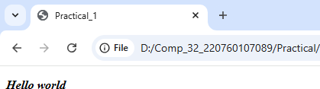

## **Aim:-** Display various text formatting methods available in HTML.(i.e.&lt;h1&gt;,&lt;b&gt;,&lt;u&gt; etc…)

<!DOCTYPE html>

<html>

<head>

<title>

Practical_2

</title>

</head>

<body bgcolor="silver">

<h1><b><u>Harshil Patel</u></b>

<br>

</h1>

</body>

</html>

# Output:-

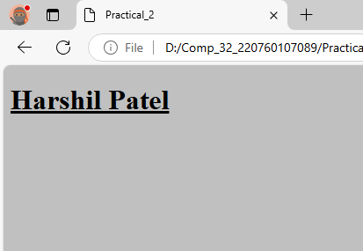

## **Aim:-** Create a HTML file using special characters.

<!DOCTYPE html>

<html>

<head>

<title>

Practical_3

</title>

</head>

<body>

<p><blink><font color="red" size="15"><mark>Spacial symbol</mark></font></blink></p>

<p>&amp;</p>

<p>&copy;</p>

<p>&hearts;</p>

</body>

</html>

# Output:-

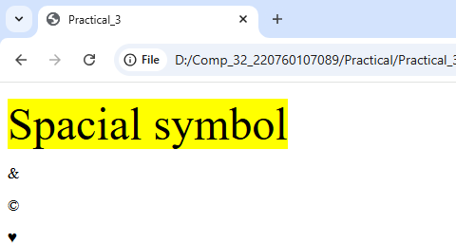

## **Aim:-** Create a HTML file which displays 3 images at LEFT, RIGHT and CENTER respectively in the browser<!DOCTYPE html>

<!DOCTYPE html>

<html>

<head>

<title>

Practical_4

</title>

</head>

<body>

<p align="left"><img src="p4_image1.jpg" alt="p4_image1"></p>

<p align="center"><img src="p4_image2.jpg"alt="p4_image2"></p>

<p align="right"><img src="p4_image3.jpg" alt="p4_image3"></p>

</framesets>

</body>

</html>

**Output:-**

